**CS157B**

**Assignment 3**

**Hardcopy**

1. **Description**

Four-Step Dimensional Design Process

Business model: Chain-retail stores

1. In this Assignment, my business process is of a chain retail store that make sells, my business model focuses on the total daily sales of made by each store.
2. The grain is one row per store each day, which means the sales of each store during each day.
3. The dimensions of this business model is:  
   Date: day<month<quarter<year  
   Store: storeID<city<county<state<country
4. The Fact is the sales in dollar of each store during each day.
5. **ER Diagram**

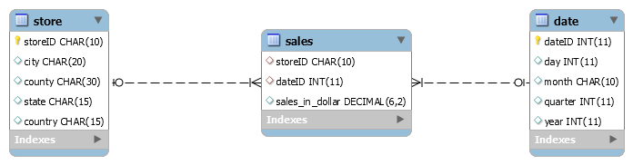

1. **Instructions**
2. Create database, (Ex: Create database hw;)
3. Use database, (Ex: use hw;)
4. Run schema.sql to create tables ( type in mysql console “SOURCE C:\file\location\schema.sql”)
5. Run data.sql to populate tables (type in mysql console “SOURCE C:\file\location\data.sql”)
6. Run query files to see OLAP operations, file names: base.sql, rollup.sql, drilldown.sql, slice.sql and dice.sql (type in mysql console “SOURCE C:\file\location\base.sql” replace base.sql with name of the desired OLAP operation),
7. **Base query**

SELECT f.storeID, s.city, s.county, month, year, sum(sales_in_dollar) sales FROM sales f, store s, date d WHERE f.storeID = s.storeID AND f.dateID = d.dateID GROUP BY f.storeID, month;

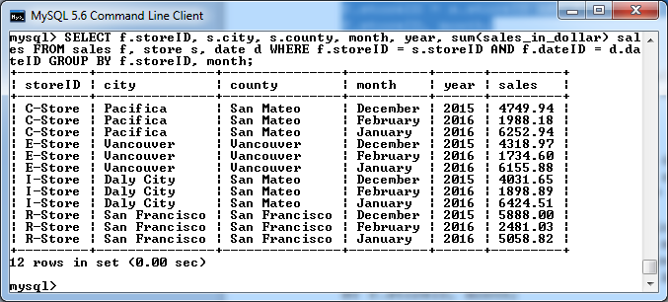

1. **Roll up query (storeID -> county)**

SELECT s.county, month, year, sum(sales_in_dollar) FROM sales f, store s, date d WHERE f.storeID = s.storeID AND f.dateID = d.dateID GROUP BY county, month;

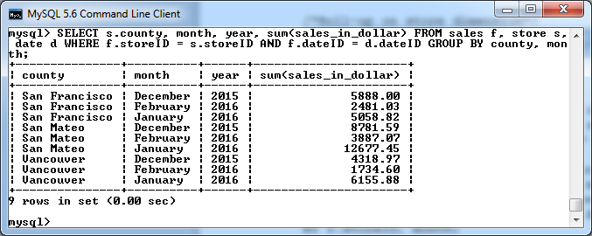

1. **Drill down query (month -> day)**

SELECT f.storeID, s.city, s.county, day, month, year, sales_in_dollar sales FROM sales f, store s, date d WHERE f.storeID = s.storeID AND f.dateID = d.dateID;

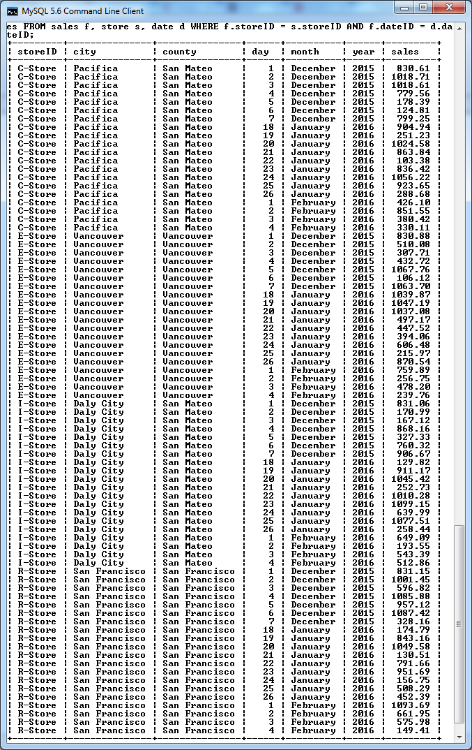

1. **Slice query (country = ‘Canada’)**

SELECT f.storeID, s.city, s.county, month, year, sum(sales_in_dollar) FROM sales f, store s, date d WHERE f.storeID = s.storeID AND f.dateID = d.dateID AND country = 'Canada' GROUP BY f.storeID, month;

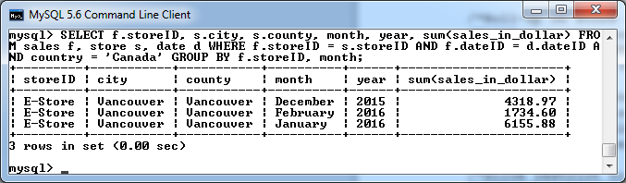

1. **Dice query (storeID = ‘I-Store’ and year = 2016)**

SELECT f.storeID, s.city, s.county, month, year, sum(sales_in_dollar) FROM sales f, store s, date d WHERE f.storeID = s.storeID AND f.dateID = d.dateID AND f.storeID = 'I-Store' AND year = 2016 GROUP BY f.storeID, month;

